Process Management Utilities
John Wensink
CSC507 Foundations of Operating Systems
Colorado State University – Global Campus
Dr. Joseph Issa
November, 24th, 2024

Process Management Utilities
Process management is the topic of the week. Both Linux and Windows provide tools to allow a user to do this manually, and the operating systems (OS) differ significantly in terms of design theory. With its command line terminal interface, Linux offers unmatched flexibility and control. Windows, on the other hand, employs a user-friendly graphical user interface (GUI) task manager and the more advanced process explorer. Today, I will explore and compare the two paradigms using Fedora to demonstrate the capabilities of a Linux OS alongside Windows 11. While most users are familiar with basic process management tasks such as listing running processes or terminating them, there is a lot more that can be accomplished to showcase the unique features along with the strengths and weaknesses of each OS’ processes management systems.
Process Isolation
Process isolation (PI) demonstrates how an OS segregates and manages processes to allocate resource ownership, prevent interference, and ensure stability. Linux and Windows have distinct ways of achieving isolation. In Linux, PI is achieved using Process ID (PID) Namespaces. Processes inside a namespace have their own PID hierarchy. Within the util-linux package, the unshare command can be used to isolate a PID namespace. It turns out that util-linux comes installed by default on Fedora, and I did not have to go through the trouble of using dnf install util-linux, but it’s interesting to note that RedHat doesn’t use apt-get that I am used to using in Debian based distributions. We are changing system configurations here, so we’ll have to use the superuser modifier sudo to run the command with administrative privileges. The command sudo unshare –pid –fork bash will allow Fedora to execute a program in a new namespace, –pid specifies to create a new PID namespace and gives processes an independent PID hierarchy starting with PID 1, –fork starts a child process, and bash becomes PID 1 within the new namespace (Ahao, 2024.) After this is created, running the command ps shows we have a new PID 1 systemd.
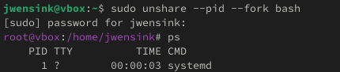
I was actually expecting to see bash here instead of systemd, it turns out Fedora automatically invokes systemd when sudo spawning a new namespace when using the unshare command as the default init system. This is tied to Fedora’s use of systemd to handle other process management tasks like reaping orphaned child processes more effectively than a basic bash shell.
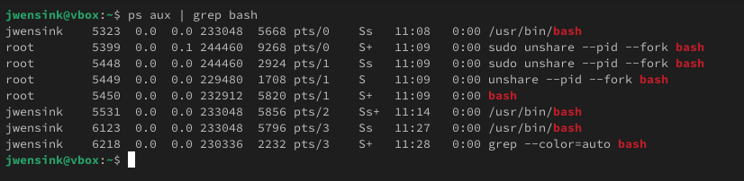

In Windows, process isolation works a bit differently. Windows doesn’t have a direct equivalent to Linux namespaces, but there are a few workarounds (Microsoft, 2023.) Windows can create a job object and set restrictions on memory usage, similar to how Linux namespaces can isolate a process. Using Powershell, we can import the .NET framework and Windows APIs to create a new job object using the CreateJobObject function. Once the job object was created, we used the AssignProcessToJobObject function to associate an already running process (Notepad, for this example) with the job object. I used ChatGPT (OpenAI, 2024) to generate the script for me, and it did an excellent job. 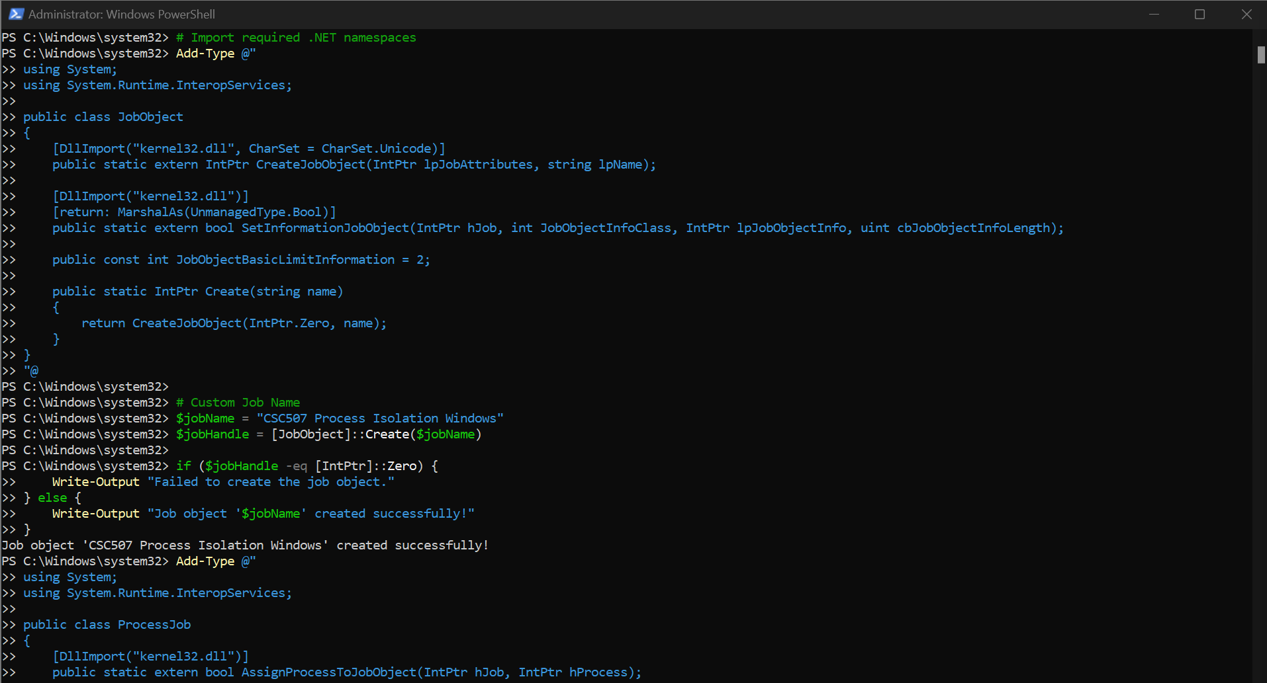
Task Manager is Windows’ default process monitoring system and is fine for most purposes, but a less commonly used system, Process Explorer provides more advanced capabilities beyond what Task Manager can offer, in this case verifying the association of the notepad process with our newly created job object. Process Explorer confirmed that the notepad.exe process was successfully linked to the “CSC507 Process Isolation Windows” job object. If we wanted to restrict CPU or memory usage or select a processor core affinity for the job object, Task Manager would offer some limited functionality to implement restrictions. However, for implementing more precice restrictions, another PowerShell script would have needed to be created.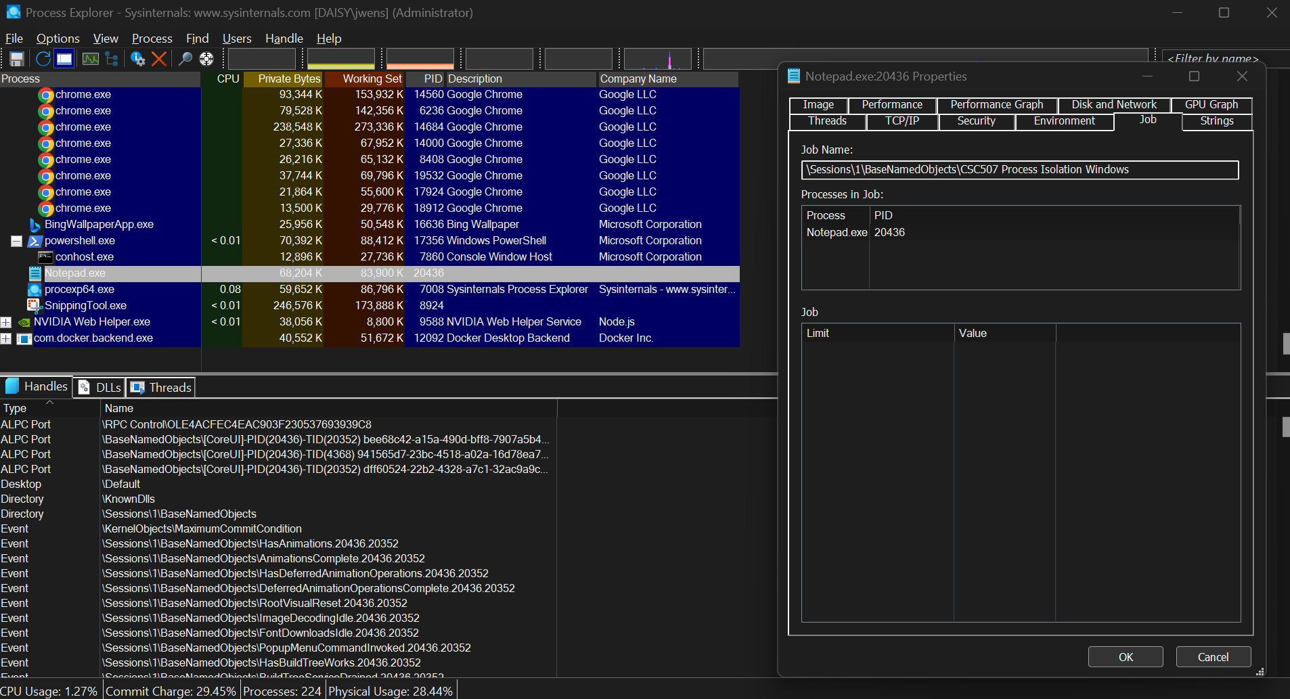
Monitor Disk I/O Processes
There are many different approaches to monitoring disk I/O processes in Linux (Unix and Linux Stack Exchange, 2012.) One could use a built-in command like vmstat to provide a quick overview of disk performance, including an overview of blocks read and written per second. Alternatively, the command
cat /proc/diskstats would allow a user to view raw data about disk activity directly from the kernel. For information about a specific process, the command cat /proc/<PID>/io if you know the PID of the process you wish to monitor. There are also numerous tools like iostat, or sar that are available as part of the sysstat package, which I would recommend to anybody taking a Linux OS class. These tools offer more detailed functionality, enabling a user to view I/O statistics over time or for specific devices. Additionally, dstat provides real-time and customizable views of I/O activity metrics. Another useful tool is the iotop package, which provides a view similar to the top command for monitoring CPU and memory usage. For a more visual representation, tools like atop and htop include I/O metrics alongside processor and memory statistics for a more in-depth monitoring experience.
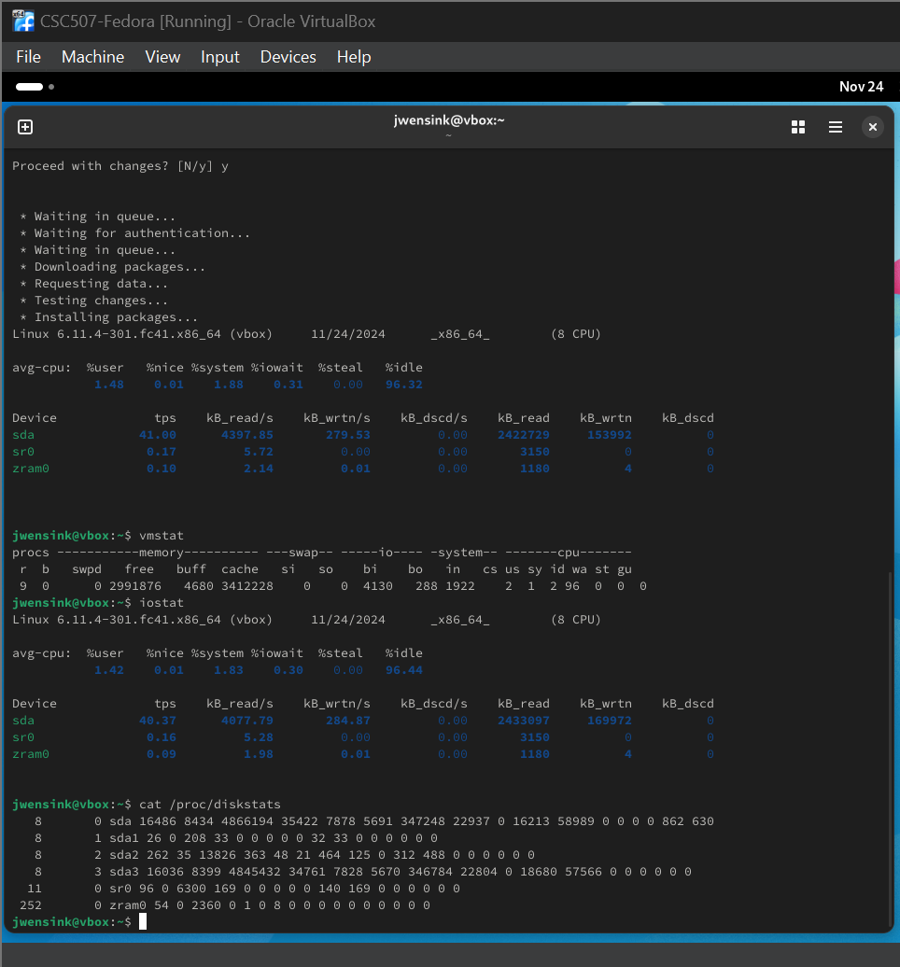
For Windows, the Task Manager does a decent job of monitoring I/O operations for individual processes. By enabling columns for I/O Reads and Writes, I/O Bytes Read and Written in the details tab, a user can get a great graphical representation of how much data each process is reading or writing to the disk. What’s nice about this is you can sort by name, PID, or utilization, depending on your use case. 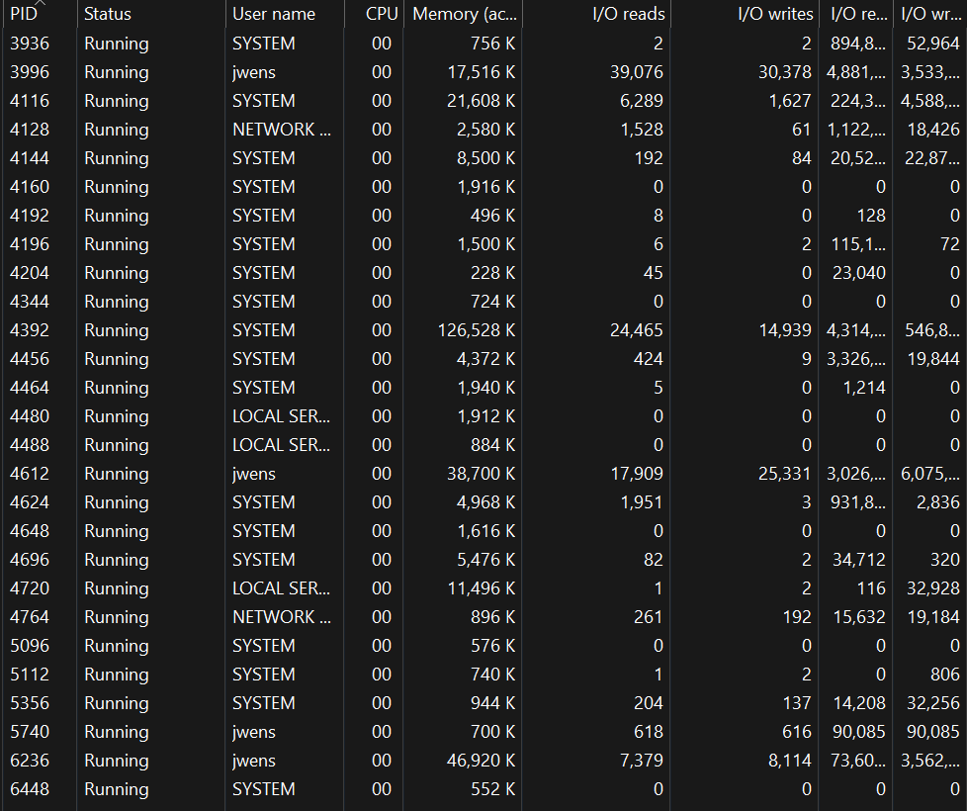
If more advanced metrics are needed, the Performance Monitor is another built in tool that provides a tremendous amount of data about I/O operations. Performance Monitor allows users to customize counters which makes it ideal for longer-term monitoring or detailed analysis of disk activity. Performance monitor has a graphical view and a textual view that can be customized to provide advanced insight into system performance.
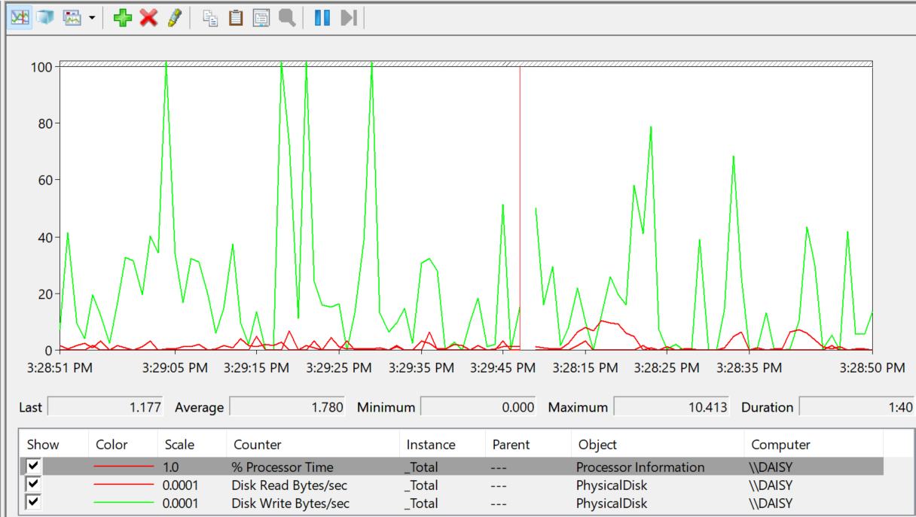
Trace System Calls
Tracing system calls is another way to highlight the differences between Linux and Windows. In Linux, the strace command offers a view into the interaction between a process and the kernel. strace is invaluable when it comes to debugging a program that is failing to execute properly (GeeksforGeeks, 2024.) Let’s take, for example, the simple command ls, a simple command to list the contents of a directory, one of the most basic and commonly used commands. When we run the command strace -e open,read,write,close ls we can see how the ls command interacts with the operating system at a very low level. The strace utility reveals that ls first opens the current directory with some system read calls made by the ls process. These calls involve reading 832 bytes of data at a time from the file descriptor 3, which is associated with the open directory. The hex displayed represents the binary data processed by ls. The next line shows a single system write call that outputs the processed directory content to the terminal to show the directory names Desktop, Documents, Downloads, etc. This got written to file descriptor 1 which corresponds to standard output to the terminal. We can see that 72 bytes of data were written. The exit status +++ exited with 0 +++ confirms that ls executed successfully, as 0 is the code for a successful operation. 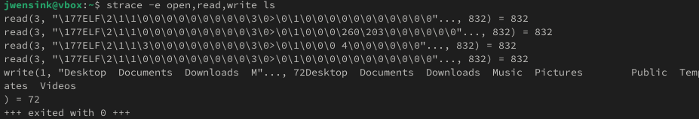
In Windows, we will need to use a system tool called Process Monitor to capture and analyze a process's system interactions. Process Monitor is another part of the Sysinternals suite. Similar to Process Explorer, ProcMon provides a real-time view of all file systems, registry, and process/thread activity that occurs in the system. For a demonstration, I used Windows Command Prompt to list the contents of a directory using the command dir. With ProcMon, we can trace the operations performed by cmd.exe, such as file access, directory queries, and cleanup. The captured events can provide insights into how the dir command interacts with the system at a low level. This can be a powerful tool for debugging and understanding process/thread behaviors in the Windows OS.
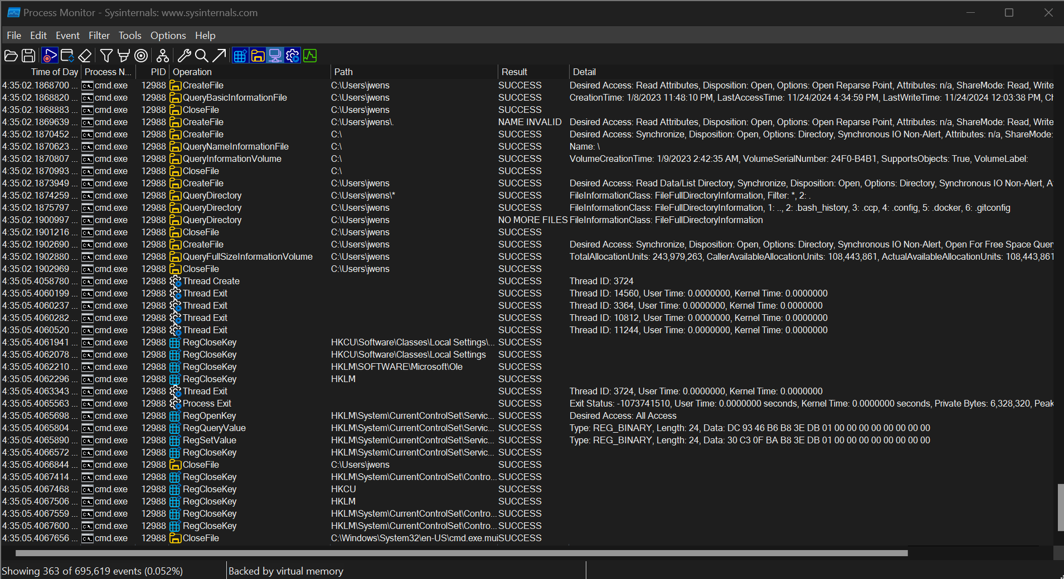
CPU Affinity
Setting CPU affinity allows a process to run on specific CPUs, which can be useful for optimizing a process's performance. In Linux, taskset is a command that can be used to set the CPU affinity of a process (Gökmen, 2022.) To get started with a demonstration, we will need to create a long-running process, sleep seems like a good choice. To do this, I opened a terminal and used the command sleep 1000 & to start a background process that will run for 1000 seconds. The & modifier allows the process to run in the background and will keep the terminal free for further commands. The terminal spits out the PID (3978), and we can confirm that the process is active using the command ps -p 3978.
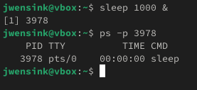
Now we’re ready to run taskset -p 3978 to show the CPUs available. The output ff means that the process currently has access to all eight available CPUs, as each bit in the mask will correspond to a CPU core. In hex, ff corresponds to 11111111, meaning that the process can run on all eight allocated CPUs. When we execute the command taskset -p 1 3978, the terminal outputs to confirm that the PID’s new affinity mask is 1. We confirm that the sleep process is now limited to running on CPU 0 as the output to taskset -p 3971 is pid 3978’s current affinity mask: 1. Since this is just a demonstration, we will kill the process using the command kill 3978. Pretty cool.
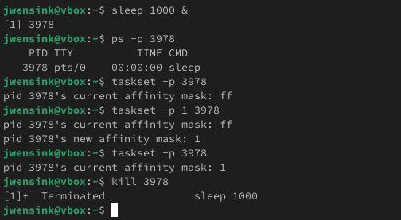

In Windows the process is much more straightforward. We start by running the command prompt and open Windows Task Manager. In the details tab, I located cmd.exe and simply right click to set affinity. A nice graphical display appears showing CPUs 0-15 with checkboxes that can be selected or unselected, I selected only CPU 15 for this demonstration.
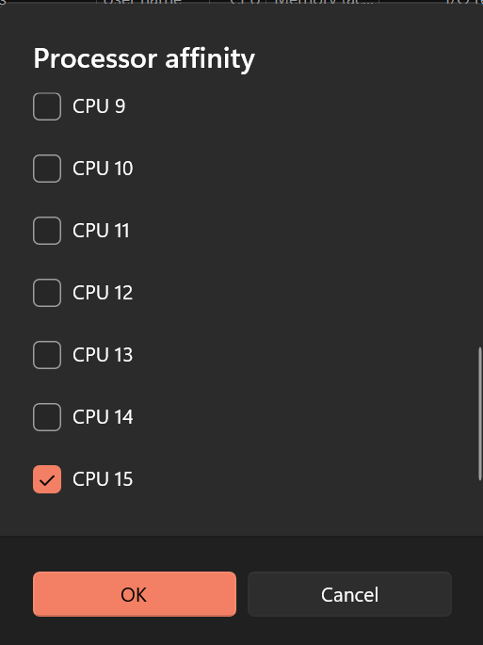
Zombie Processes
A zombie process occurs when a child process has terminated, but its parent has not yet read its exit status, leaving an entry in the process table. Besides having a cool name, it can be important to understand the implications of zombies not because they are consuming system resources but because they can still indicate a problem with parent-child process handling. Once again, we head to the terminal and start a script to generate a zombie process. I asked ChatGPT (OpenAI, 2024) how to demonstrate this functionality, and it suggested a bash script to initiate a child process using sleep, which runs in the background while the parent process quickly exits without collecting the exit status of the child. This caused the child process to remain in a terminated state but still present in the process table, becoming a zombie. To monitor this process, we can use the ps command with grep Z to identify any processes that are flagged as zombies in the status column.
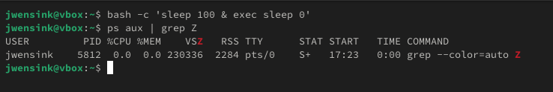
In Windows, child processes are cleaned up automatically when the parent exits, and Windows won’t retain zombie-like processes in the process table as Linux does. Rather, Windows ensures that any resources associated with a terminated process are promptly reclaimed by the operating system. This eliminates the need for a parent process to explicitly ‘reap’ their child processes. However, an orphaned process can occur if a parent process terminates abruptly without properly shutting down its children. In such cases, the child will continue to run independently, consuming system resources until they are manually terminated or cleaned up by the system. Again, I asked ChatGPT (2024) how I would be able to demonstrate this, and it recommended a PowerShell script to simulate a parent process of creating and abandoning a child process. Here we can clearly see that notepad.exe is still running even though its parent process has terminated.
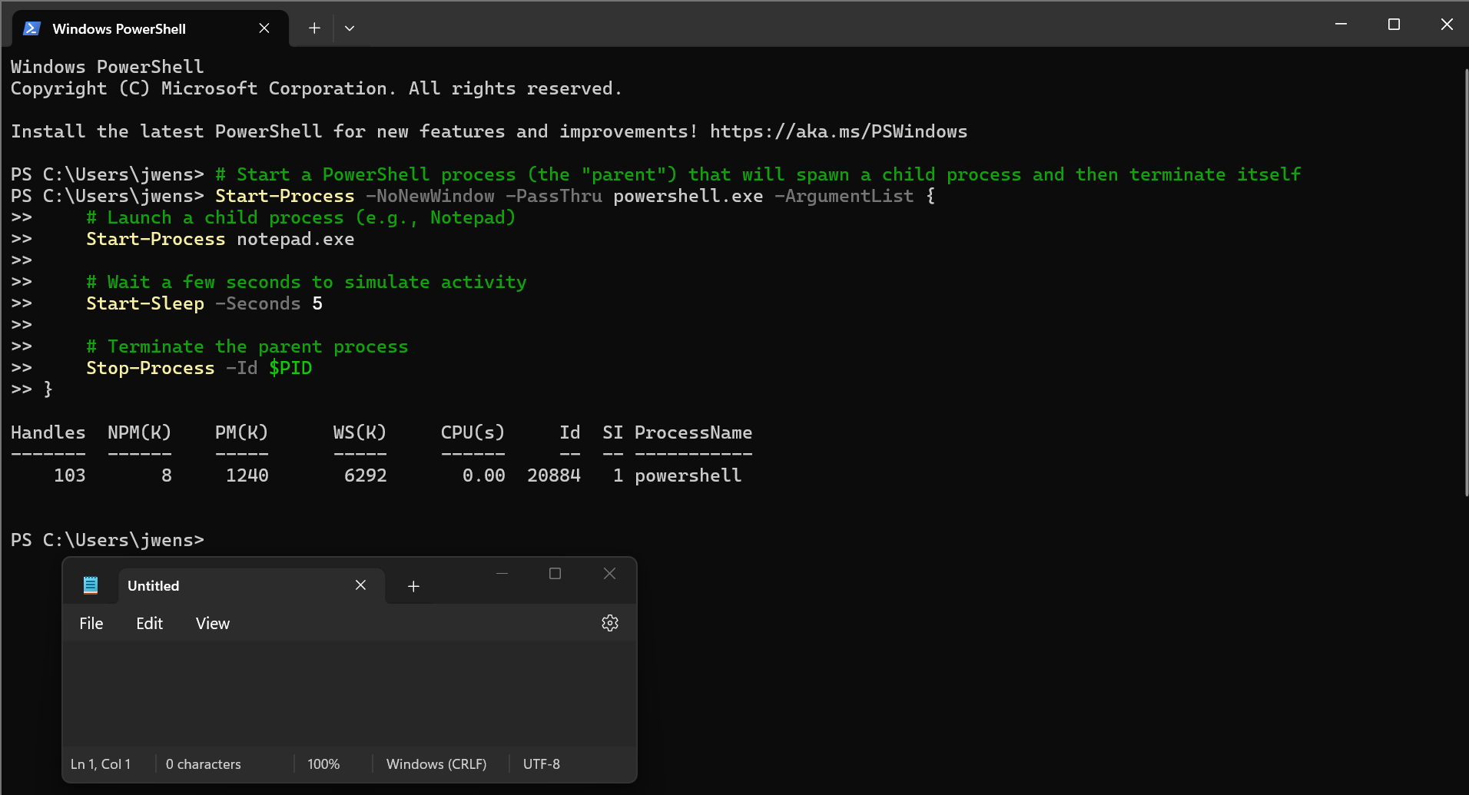
Conclusion
Linux and Windows clearly have different approaches to process/thread management due to their differing design philosophies and underlying architecture. Linux seems to provide a much more granular control over processes through the command line interface, whereas Windows seems to provide a much more graphical delivery of processes through a variety of system tools. Windows Task Manager is a tremendously powerful tool that is easy to use and familiar to the general public, however, other tools like Process Monitor and Process Explorer can provide even greater insights into what is happening behind the scenes. Ultimately, both systems offer control over user-level and kernel-level processes/threads but require different tools and methods to achieve similar goals.

References
Ahao, N. (2024, July 31). How to list namespaces in Linux. Baeldung. Retrieved November 24, 2024, from https://www.baeldung.com/linux/list-namespaces
GeeksforGeeks. (2024, September 2). Strace command in Linux with examples. GeeksforGeeks. Retrieved November 24, 2024, from https://www.geeksforgeeks.org/strace-command-in-linux-with-examples/
Microsoft. (2023, March 17). Isolation modes. Microsoft Learn. Retrieved November 24, 2024, from https://learn.microsoft.com/en-us/virtualization/windowscontainers/manage-containers/hyperv-container
OpenAI. (2024). Chat with ChatGPT-4o. Retrieved November 24, 2024, from https://chat.openai.com

